**DSA0187: OBJECT ORIENTED PROGRAMMING WITH C++**

Test-2:

31. print the pattern 1 22 333 4444 55555

#include <iostream>

int main() {

int rows;

std::cout << "Enter the number of rows: ";

std::cin >> rows;

for (int i = 1; i <= rows; ++i) {

for (int j = 1; j <= i; ++j) {

std::cout << i;

}

std::cout << std::endl;

}

return 0;

}

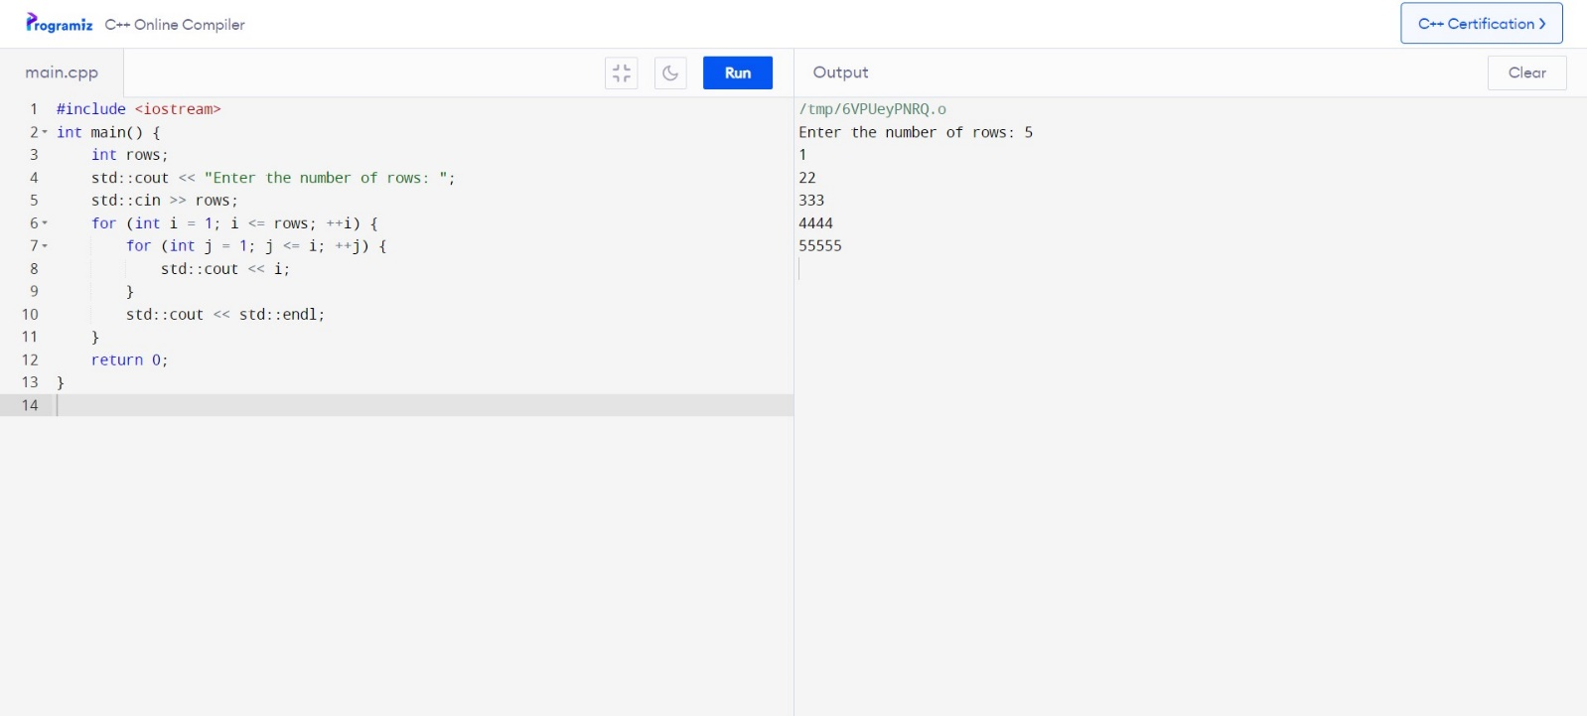

39. Find the average of all elements in an array

#include <iostream>

int main() {

int size, sum = 0;

const int maxSize = 100;

int arr[maxSize];

std::cout << "Enter the size of the array: ";

std::cin >> size;

std::cout << "Enter the elements of the array:" << std::endl;

for (int i = 0; i < size; ++i) {

std::cout << "enter Element " << i+1 << ": ";

std::cin >> arr[i];

sum += arr[i];

}

double average = static_cast<double>(sum) / size;

std::cout << "Average of array elements: " << average << std::endl;

return 0;

}

